Mid Term Discipleship Command K: Forgive

Look Back:
1-4 Focus the entire look back portion of your time as a church on one person or couple by doing an Iron on Iron session with them.

Look Up:
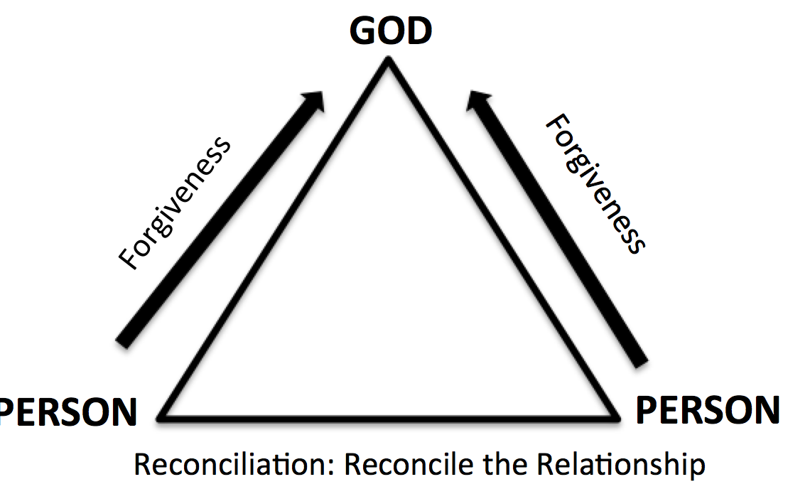
5. New Lesson. Study Matthew 18.21-35 using the SWORD Method.

Look Ahead:
6. Practice. Forgiveness has two components: letting them out of the dungeon of your heart and releasing the their debt towards you. (Mt. 18: 30) Forgiveness is between you and God. We are commanded to forgive like Jesus forgives. If you don’t forgive, you will feel tortured. (Mt. 18:35) It does not mean the relationship is reconciled. It means we have released them of the debt to us and let them go from the dungeon of our hearts.

Write down a list of the people that have hurt you. Ask yourself if you have forgiven them. If you have forgiven them have you tried to reconcile with them? (Look at the lesson on Reconciling)

If you haven’t forgiven, ask God to help you forgive them right now. Talk with your church if you are having trouble forgiving someone. One of the keys to forgiving others is looking at Jesus who forgave us all when we didn’t deserve it. (Luke 23:34)

7. Goal Setting and Prayer. Pray and ask the Holy Spirit how to respond.
- Following: Are there any relationships in your life where you didn’t tell the person you forgive them? Who do you need to reach out to today to let them know you forgive them just like Christ has forgiven you?

- Fishing: Jesus Christ has already paid the price for us to be forgiven (Acts 10:43). How should you share the gospel this week to help people receive forgiveness and reconciliation with God?

