Mid Term Discipleship Command I:
Invest and Empower Leaders

Look Back:
1. Member Care.

2. Loving Accountability. Ask everyone how their following and fishing goals went.
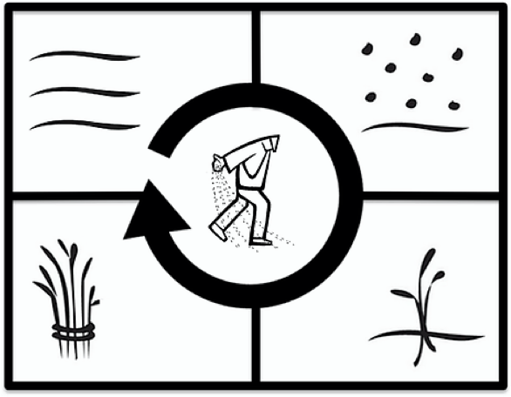
3. Worship and Prayer.

4. Vision Casting. Read Matthew 9.35-10.13 and share the Four Fields Strategy. Watch this video for help: https://www.youtube.com/watch?v=pwvO3rB6pSM&t=70s

Look Up:
5. New Lesson. Study Mark 3.13-21 using the Sword Method.

Look Ahead:
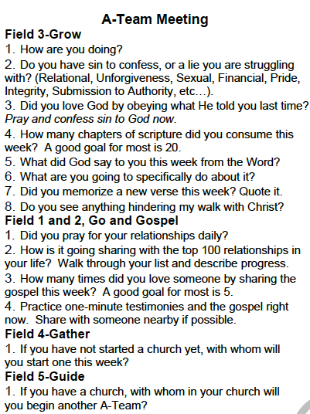
6. Practice. For the sake of Kingdom growth, leaders need more time for investment and empowerment. If you have started a church, think through who are the people in your church who are most likely to start the next church. Make a plan to meet with this leader using the Accountability Team (A-Team) Format.

Practice meeting in the A Team in same gender groups now. When A teams begin it is rare to be able to work through all the questions in a one hour sitting. Over time you should be able to work through all the questions in one hour. Keep A-teams to 2 or 3 people. Only meet in A teams with leaders in your church who are faithfully obeying the short term discipleship lessons.

7. Goal Setting and Prayer. Pray and ask the Holy Spirit how to respond.
- Following: Who do you need to meet with in A team?

- Fishing: How many people and with whom do you need share the gospel this week?

