Mid Term Discipleship Command H:
Find Good Soil

Look Back:
1. Member Care.

2. Loving Accountability. Ask everyone how their following and fishing goals went.
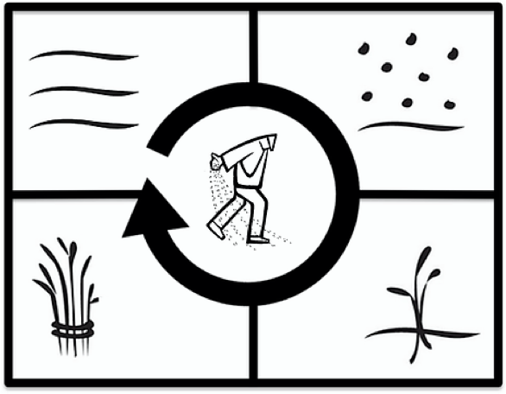
3. Worship and Prayer.

4. Vision Casting. Read Matthew 9.35-10.13 and share the Four Fields Strategy. Watch this video for help:

Look Up:
5. New Lesson. Study Matthew 13.1-23 using the Sword method.

Look Ahead:
6. Practice. The main distinction of the good soil is that it multiplies what is sown into it.

If you have started a church, think through the people in your church. Who are the people who are behaving most like good soil? Who are the people who seem to have thorns in their life that need to be addressed?

If you have not started a church, look through your relationship list. Who are the people who are most behaving like good soil. Who are the people that seem to have thorns in their life that need to be addressed?

7. Goal Setting and Prayer. Pray and ask the Holy Spirit how to respond.
- Following: Pray and meditate on Matthew 13.1-23. Who are the good soil people that you need to encourage and begin to develop? Who are the thorny soil people that you need to exhort to keep them from being choked? Pray and ask God for a plan to encourage and exhort as necessary. Share your plan with your church and record it.
- Fishing: The good soil multiplies abundantly--a minimum of 30 times what is sown. How is the Holy Spirit leading you to scatter seed this week? Look through your relationship list, who still needs to hear.

