Mid Term Discipleship Command F:
Search for a Worthy Person

Look Back:
1. Member Care.

2. Loving Accountability. Ask everyone how their following and fishing goals went
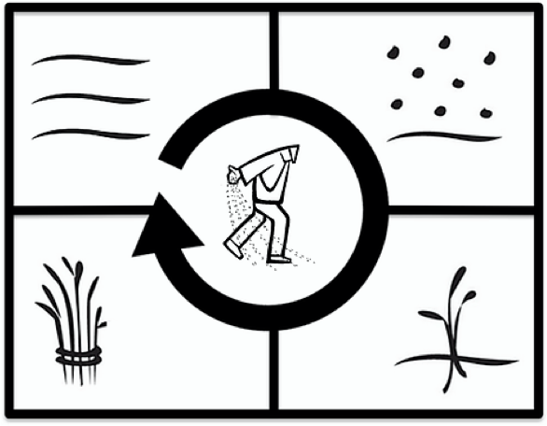
3. Worship and Prayer.

4. Vision Casting. Read Matthew 9.35-10.13 and share the Four Fields Strategy. Watch this video for help:

Look Up:
5. New Lesson. Read Matthew 9.35-10.13 two times. The first time record how Jesus operates in each of the four fields. The second time record how he instructs the apostles to operate in each of the four fields.

Look Ahead:
6. Practice. Develop a micro vision for your relational network and area. A good framework is:
- Go: Number of Seed Sowers trained in Lesson 0.
- Gospel: Number of Gospel Shares and Baptisms.
- Grow: Number of Disciples trained and obedient to the Short Term Discipleship Commands.
- Gather: Number of churches planted.
- Guide: Number of 2nd and 3rd gen churches led by new leaders.

Practice sharing the four fields strategy with another believer to cast vision to them and ask for their help in realizing your micro vision. Make sure you can do it orally and by drawing the picture. Practice in pairs so that everyone gets at least five attempts. Include the micro vision you are inviting other disciples to.

7. Goal Setting and Prayer. Pray and ask the Holy how to respond.
- Following: Ask God which existing believers to share the Four Fields and your micro vision with this week.
  - Record a church goal for the number of people to train or cast vision to this week.
- Fishing: Preach the Gospel of the Kingdom. Pair people up this week to go out two by two to share the gospel in a neighborhood or public place. Pray and ask God where and with whom you should go. Normally, team the bold with the less bold.
  - Record a church goal for the number of people to share with this week.
- Pray for each other and commission each other before leaving.

