Mid Term Discipleship Command E:
Know Jesus in All the Scripture

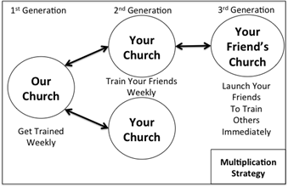
Look Back:
1. Member Care.

2. Loving Accountability. Ask everyone how their following and fishing goals went

3. Worship and Prayer.

4. Vision Casting. Review Matthew 13.31-32 and coach the multiplication strategy to the right.

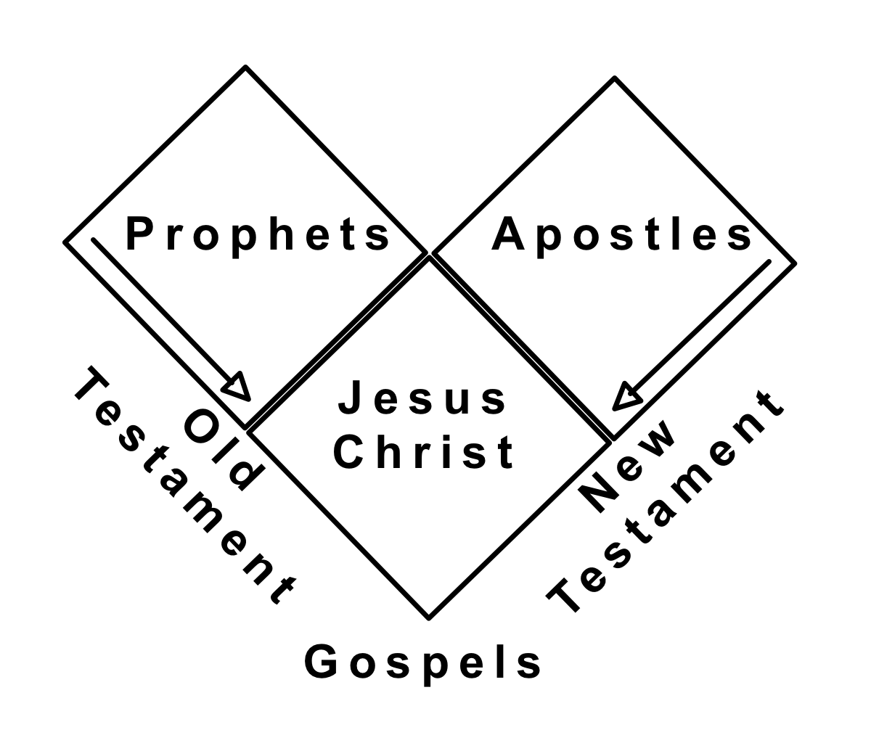
Look Up:
5. New Lesson. Study Luke 24.13-27 using the SWORD method.

Look Ahead:
6. Practice. The Jews in Jesus day searched the scriptures, but missed Jesus (Jn 5.39). To avoid this disciples must read the entire bible, and read it in light of Jesus Christ. The Prophets (OT) and the Apostles (NT) both point to Jesus (Eph 2.19-20). Moses and the Prophets point forward to Jesus (Lk 24.27) and the Apostles point back to him (Acts 4.33). Practice sharing this picture with each other.

7. Goal Setting and Prayer. Pray and ask the Holy Spirit how to respond.
- Follow: Consider the chart at the bottom. Develop a plan for reading the entire bible, while keeping your eyes fixed on Jesus in the gospels. Pray and ask God much scripture should you consume this week to get started?
# chapters to read daily | OT | NT | G | Yearly
1 |  |  | 1 | Gospels x4
3 | 1 | 1 | 1 | Gospels x4, NT x2, OT x 1/3
5 | 3 | 1 | 1 | Gospels x4, NTx2, OT x1

- Fish: How does Jesus want you to share the gospel this week? Ask him and His Holy Spirit will tell you.

Share your following and fishing goals with your church. Pray for each other.

