Mid Term Discipleship Command D:
Always Pray

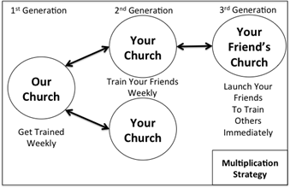
Look Back:
1. Member Care.

2. Loving Accountability. Ask everyone how their following and fishing goals went

3. Worship and Prayer.

4. Vision Casting. Review Matthew 13.31-32 and coach the multiplication strategy to the right.

Look Up:
5. New Lesson. Study Luke 18.1-8 using the SWORD method.

Look Ahead:
6. Practice. Pray for an hour in five minute increments using the prayer wheel. You can do this as a church or privately.

7. Goal Setting and Prayer. Pray and Ask the Holy Spirit how to respond.

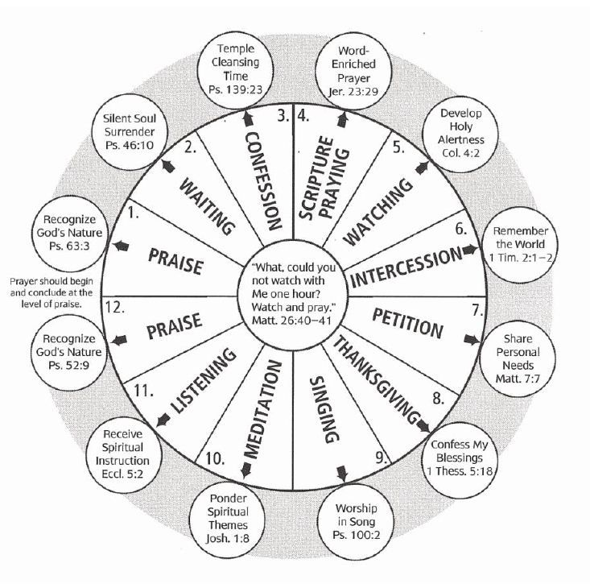
- Follow: Meditate on Luke 18.1-8 and ask the Holy Spirit how much he’d like you to be praying this week. Share what he says with your church. How many hour prayer sessions do you want to do?

- Fish: Ask the Holy Spirit how many times and with whom you need to share the gospel this week. Ask if there is anyone you need to equip to share the gospel.

