Mid Term Discipleship Command C:
Rejoice in Persecution

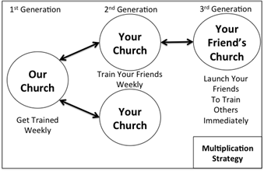
Look Back:
1. Member Care.

2. Loving Accountability. Ask everyone how their following and fishing goals went.

3. Worship and Prayer.

4. Vision Casting. Review Matthew 13.31-32 and coach the multiplication strategy to the right.

Look Up:
5. New Lesson. Study Matthew 5.1-16 using the Sword Method.

Look Ahead:
6. Practice. Retrieve or recreate your 100 name relationship list. The A Team prayer card is a good way to make this list. Look through the list for the people that you feel the most persecution or animosity from. Pray for them right now.

Imagine how you could share the gospel with the scariest people on your relationship list. Role play with your friends in your church how you would share with these people. Coach each other to be more bold.

7. Goal Setting and Prayer. Pray and ask the Holy Spirit how to respond.
- Following. Reflect on Jesus’s words from Matthew 5.1-16. How do you need to pray and read the scripture this week in light of his teaching and promises.

- Fishing. How should you share the gospel this week? Pray and make a plan to share with the scariest people on your relationship list this week?

