Mid Term Discipleship Command B:
Manage the Master’s Resources

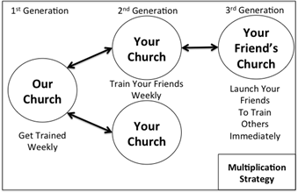
Look Back:
1. Member Care.

2. Loving Accountability. Ask everyone how their following and fishing goals went.

3. Worship and Prayer.

4. Vision Casting. Review Matthew 13.31-32 and coach the multiplication strategy to the right.

Look Up:
5. New Lesson. Study Matthew 25.14-30 using the Sword Method.

Look Ahead:
6. Practice. One of the most precious resources that Jesus has entrusted to you is your relationships. You are responsible for taking the gospel to them. Most people have about 100 meaningful relationships.

Make a list of your closest 100 friends, regardless of whether you think they are believers or not. The A Team prayer card is a good way to do this. This list approximates the relationships you are responsible for.

Mark “shared” next to every person you have personally invited to trust Jesus as King. Mark “trained” next to every believer you have trained in lesson 0.

7. Goal Setting and Prayer. Pray and ask the Holy Spirit how to respond.

- Following. None of the people on your list will trust Jesus as King or begin sharing him apart from the work of the Holy Spirit. How much do you need to pray for this list this week?

- Fishing. Pray over your full name list now. Ask God who do you still need to share the gospel with and who do you need to train. Share your plan with your church to finish sharing with and training everyone on your list.

See https://www.youtube.com/watch?v=O2qjRG6iV8M. Most actually have about 150 according to social scientist Robin Dunbar. We choose 100 because it’s easy to remember and leaves room for those with a few less friends.

