Mid Term Discipleship Command A:
Be Taught By the Holy Spirit

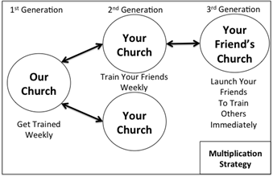
Look Back:
1. Member Care.

2. Loving Accountability. Ask everyone how their following and fishing goals went.

3. Worship and Prayer.

4. Vision Casting. Review Matthew 13.31-32 and coach the multiplication strategy to the right.

Look Up:
5. New Lesson. Study John 14.15-27 using the SWORD method.

Look Ahead:
6. Practice. Read John 15.26-16.15 and Galatians 5.16-26. Make a list of the things that you find that characterize the work of the Holy Spirit (some may be what doesn’t characterize His work). You might want to do this in two groups.

Once you have finished your list, pray and ask the Holy Spirit to affirm one way His character is seen in you and one way in which His character needs to shine through more. Share with your church, pray and thank God for his work.

If you don’t feel like these fruits are manifesting in your life at all ask yourself: “Have I truly let Jesus be my King?” If Jesus is your King, than ask God to help you keep in step with His Spirit in you. (Gal. 5:25)

7. Goal Setting and Prayer. Remember, the Holy Spirit is your teacher. Your human leaders are like tutors to help you learn what he’s teaching you. Every Mid Term discipleship lesson will ask you to respond to the work of the Holy Spirit based on teaching from the Holy Scripture. This will happen in the Goal Setting and Prayer portion.

- Following. For this lesson look at the list you made and share one practical and measurable step to be more led by the Holy Spirit.

- Fishing. Pray and ask the Holy Spirit with whom or how many times you should be sharing the gospel this week. A good pattern is to share with 5 weekly.

