Mid Term Discipleship Command 0: Obey Jesus

Look Back:
1. Member Care. Everyone share one “Say” from something they read in the word.

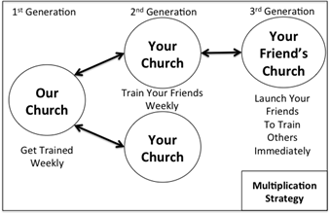
2. Loving Accountability. Take up the offering you committed to last week. Have everyone answer the question, “How did it go sharing the gospel this week?”

3. Worship and Prayer. Pray and thank God for obedience and praise His name.

4. Vision Casting. Review Mat. 13.31-32. Coach the multiplication strategy. Ask everyone about training new disciples and starting churches. Address obstacles.

Look Up:
5. New Lesson. Use the SWORD method to study Matthew 7.24-27.

Look Ahead:
6. Practice. As a church, review the chart below and evaluate how you are doing at obeying Jesus’ Commands.
# | Command | Example  (How are we doing?) | Corporate Evaluation | Personal Evaluation
0 | Make Disciples | Share Testimony and Gospel 5 times per week, Train those who believe
1 | Get Baptized | Be baptized personally, baptize new believers immediately
2 | Follow and Fish | Share the Gospel through the Two Kingdoms; Train Others to Share
3 | Abide in the Word | Read 20 chapters per week, record SOS
4 | Meet Together | Meet regularly as a church; add missing elements to become healthier
5 | Put Kingdom First | Re-prioritize time and money; giving as a church
7. Goal Setting and Prayer. Pray and ask the Holy Spirit how to respond:
- Following: Ask yourselves if you are ready to move on to more content or if you need to re-train on any of the foundational lessons. Commit to necessary retraining before moving on to any new content.
- Fishing: Set a goal as a church for how many times you believe the Lord would like you to share in a given week.
  - Record the two above goals as collective church goals for the next week.

